**ABARILELA, AKAMURIE, ARUTE,**



**LIFE LINE N/P, OIDALA, OCAL,(AAALOO)**

**EXAMINATION DESK**

**PRE-SAMPLE MOCK EXAMINATION 2024**

**SCIENCE (ITEM 1 of 4)**

|  |  |  |  |  |  |  |  |  |
| --- | --- | --- | --- | --- | --- | --- | --- | --- |
| ***EMIS No.*** | | | | | | ***Personal No.*** | | |
|  |  |  |  |  |  |  |  |  |

**Candidate’s Name:…………………………………………………………………………………… Candidate’s Signature:……………………………………………………………………………… District ID No.**

**Read the following instructions carefully.**

|  |  |  |
| --- | --- | --- |
| **FOR EXAMINERS USE ONLY** | | |
| **QN. NO.** | **MARK** | **SIGN** |
| **1 - 10** |  |  |
| **11 - 20** |  |  |
| **21 - 30** |  |  |
| **31 – 40** |  |  |
| **41 – 43** |  |  |
| **44 – 46** |  |  |
| **47 – 49** |  |  |
| **50 – 52** |  |  |
| **53 – 55** |  |  |
|  |  |  |

1. This paper is made up of two Sections: A and B.

2. Answers to both sections must be written in the spaces provided in full sentences.

3. Section A has 40 questions (40 marks)

4. Section B has 15 questions (60 marks)

5. Attempt all questions. All answers to both sections A

and B must be written in the spaces provided.

6. All answers must be written in blue or black ballpoint pen or ink but not in pencil. All work done in pencil, except diagrams, will **NOT** be marked.

7. Crossing out of answers will lead to loss of marks.

8. Any handwriting that cannot be easily read may lead to loss of marks.

**TEL: 0779874282 FOR SAMPLE TEST Page 1**

**SECTION A (40 marks**

1. Identify the group of vertebrate that feeds its young one on milk from mammary gland.

_______________________________________________________________________________

2. What is capacity? _______________________________________________________________________________

3. Give one difference between plants and animals though they are all living things. _______________________________________________________________________________

4. Write the component of soil that is formed from plant and animal remains. _______________________________________________________________________________

**The diagram below shows a type of weather in our environment. Use it to answer questions 5 and 6.**

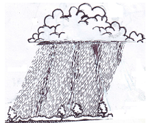

5. Which condition of weather is shown in above diagram? _______________________________________________________________________________

6. How can you protect yourself from the danger of the above type of weather? _______________________________________________________________________________

7. State the functional difference between arteries and veins. _______________________________________________________________________________

8. Under what condition would you advise a poultry farmer to carry out culling? _______________________________________________________________________________

9. Give one way through which pineapples are propagated. _______________________________________________________________________________

10. Mention the property of air that helps a P.6 pupil drink soda from a bottle using a straw. _______________________________________________________________________________

11. Apart from filtration, name one other method that is used to obtain clear water for washing.

**In the diagram below, normal bean seeds were planted and the conditions shown in the experiment. Study the diagram and use it answer questions 12 and 13.**

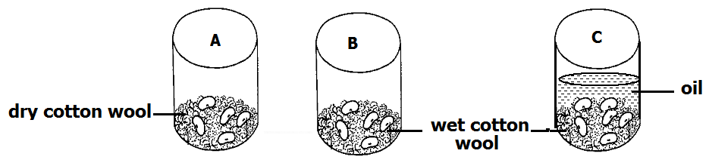

12. What condition is missing in container A? _______________________________________________________________________________

13. State the role played by cooking oil in container C. _______________________________________________________________________________

14. Define the term “addiction” as used in drugs use. _______________________________________________________________________________

16. Why is it important to carry out mulching in crop growing? ______________________________________________________________________________

17. How is the soap useful when bathing? _______________________________________________________________________________

18. Apart from rain and lakes, state any one natural source of water. _______________________________________________________________________________

19. Give one plant that can be grouped together with Mosses. _______________________________________________________________________________

20. What is soil conservation? _______________________________________________________________________________

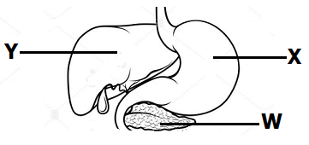**The diagram below shows part of the digestive system. Use it to answer questions 21 and 22.**

21. Name the part marked W. _______________________________________________________________________________

22. Where is the digestive juice produced at part marked Y stored? _______________________________________________________________________________

23. Which sense help you to identify the colour of a cloth? _____________________________________________________________________________

24. Give one advantage of using paddock grazing in livestock management. _______________________________________________________________________________

25. How often should one brush teeth? _______________________________________________________________________________

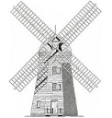**The diagram below is of a device driven by one of the resources in our environment. Use it to answer questions 26 and 27.**

26. Name the above device. _______________________________________________________________________________

27. State the resource that enables the above device to work. _______________________________________________________________________________

28 How is heat different from temperature? at. _______________________________________________________________________________

29. Write down one activity of PHC that helps to promote community hygiene. _______________________________________________________________________________

30. Give one malnutritional disease known to you. __________________________________________________________________________________________

31. What type of change occurs when water changes to ice? _______________________________________________________________________________

32. Identify the product mainly got from Saanen go at.

_______________________________________________________________________________

33. Give one example of a person with special needs. _______________________________________________________________________________

34. How is the reproduction of yeast different from that of other fungi? _______________________________________________________________________________

35. In which body part does respiration take place? _______________________________________________________________________________

36. What is pitch as used in the study of sound? _______________________________________________________________________________

38. Write 3D’s in full. _______________________________________________________________________________

39. State one characteristic of arachnids. _______________________________________________________________________________

40. Mention the intestinal worm that is prevented through eating fully cooked beef or pork. _______________________________________________________________________________

**SECTION B**

41(a) what are essential drugs? _______________________________________________________________________________

______________________________________________________________________________

(b) Give one example of essential drugs. ______________________________________________________________________________

(c) Mention any one quality of an essential drug. ______________________________________________________________________________

(d) How can essential drugs be a disadvantage to us? ______________________________________________________________________________

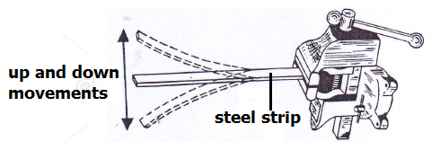42. **The diagram shows the movements of a steel strip after being twanged. Use it to answer questions that follow.**

(a) What term describes the up and down movement of the steel strip after being twanged? ______________________________________________________________________________

(b) How does the sound produced by the steel strip be heard by Peter who is 10 metres away? ______________________________________________________________________________

(c) Name one device that can be used to store the sound produce by the above ruler. ______________________________________________________________________________

(d) How can the volume of the sound produced above be increased? ______________________________________________________________________________

43. **Below are the beaks and toes of birds. Use it to answer the questions that follow.**

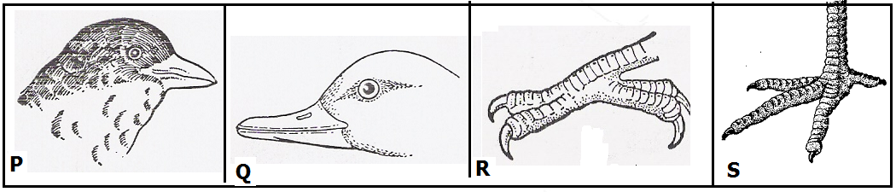

(a) In which environment does the bird with beak Q commonly found? ______________________________________________________________________________

(b) What does the bird with foot marked P feed on? ______________________________________________________________________________

(c) To which group of birds would you place the bird with beak marked R? ______________________________________________________________________________

(d) Give the importance of toes in foot marked S to the birds that have them. ______________________________________________________________________________

44(a) what is air? ______________________________________________________________________________

(b) Mention any one component of air known to you. ______________________________________________________________________________

(c) Which component of air supports the growth of bacteria? ______________________________________________________________________________

(d) How can air be a danger in our community? ______________________________________________________________________________

45(a). Mention the use of the following types of teeth in the human mouth.

(i) Canine ______________________________________________________________________________

(ii) Incisor ______________________________________________________________________________

(b) How are premolars adapted to their function? ______________________________________________________________________________

(c) In which part of a tooth are the nerves and blood capillaries found? ______________________________________________________________________________

46(a) In the space below, draw a leaf of a maize plant.

(b) Why is a maize plant regarded as an annual crop? ______________________________________________________________________________

(c) How is a maize plant propagated? ______________________________________________________________________________

(d) What is the difference between a maize plant and a fern? ______________________________________________________________________________

47(a) Mention any one component of the circulatory system. ______________________________________________________________________________

(b) Name the pigment in blood on which oxygen is carried. ______________________________________________________________________________

(c) Why should blood from the heart be pumped to the lungs before circulation to other body parts? ______________________________________________________________________________

(d) How can the circulatory system be cared for? ______________________________________________________________________________

48(a) what first aid can you give for the following injuries?

(i) Burn ______________________________________________________________________________

(ii) Near drowning ______________________________________________________________________________

(b) Identify any one cause of convulsion. ______________________________________________________________________________

(c) Give one way of preventing near drowning in our communities. ______________________________________________________________________________

49(a) Mention one breed of cattle commonly kept for beef. ______________________________________________________________________________

(b) What system of grazing cattle can one use when handling three cows in an urban place? ______________________________________________________________________________

(c) Why is pasteurization a better method of preserving milk than sterization? ______________________________________________________________________________

(d) Mention any one way of preventing viral diseases in cattle management. ______________________________________________________________________________

50(a) what type of soil has the highest capillary? ______________________________________________________________________________

(b) State one use of soil to man. ______________________________________________________________________________

(c) How can you improve on the fertility of soil without applying artificial fertilizers? ______________________________________________________________________________

(d) Give one danger of excessive application of artificial fertilizers. ______________________________________________________________________________

51(a) By what process does heat travel through a vacuum? ______________________________________________________________________________

(b) State any two effects of heat on matter. _______________________________________________________________________________

______________________________________________________________________________

(c) How is heat energy useful in our daily life? ______________________________________________________________________________

52. **The diagram below shows one of the system in the human body. Use it to answer questions that follow.**

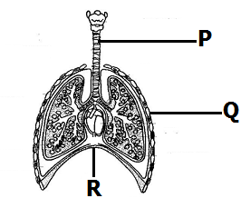

(a) Name the body system shown in the above diagram. ______________________________________________________________________________

(b) Identify part marked Q. ______________________________________________________________________________

(c) What happens to part R during breathing in? ______________________________________________________________________________

(d) Why is part marked P made of rings of cartilage? ______________________________________________________________________________

53(a) Which indicator of a dirty environment is detected by the nose? ______________________________________________________________________________

(b) State the vector that is common in places with poor sanitation. ______________________________________________________________________________

(c) How is the vector in (b) above a danger to human health? ______________________________________________________________________________

(d) Give any one principle of PHC. ______________________________________________________________________________

54. **The diagram below shows a burning candle. Use it to answer the questions below.**

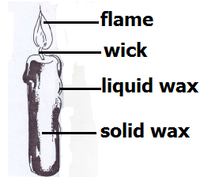

(a) Give the use of the flame above to man. ______________________________________________________________________________

(b) What type of change in the environment occurs when:

(i) solid wax melts ______________________________________________________________________________

(ii) the wick burns ______________________________________________________________________________

(c) How is the use of candle wax a danger in the environment? ______________________________________________________________________________

55(a) What is nutrition? ______________________________________________________________________________

(b) Apart from carbohydrates, which other class of food provide the body with energy? ______________________________________________________________________________

(c) Identify one food stuff that can provide the body with protein. ______________________________________________________________________________

(d) Under what condition is one advise to take food rich in iodine? ______________________________________________________________________________

**END**